***Deals on Wheels: Let the Market Show You How to Buy a Better Car***

***Modeling car prices uncovers the classics, the clunkers, and everything in between.***

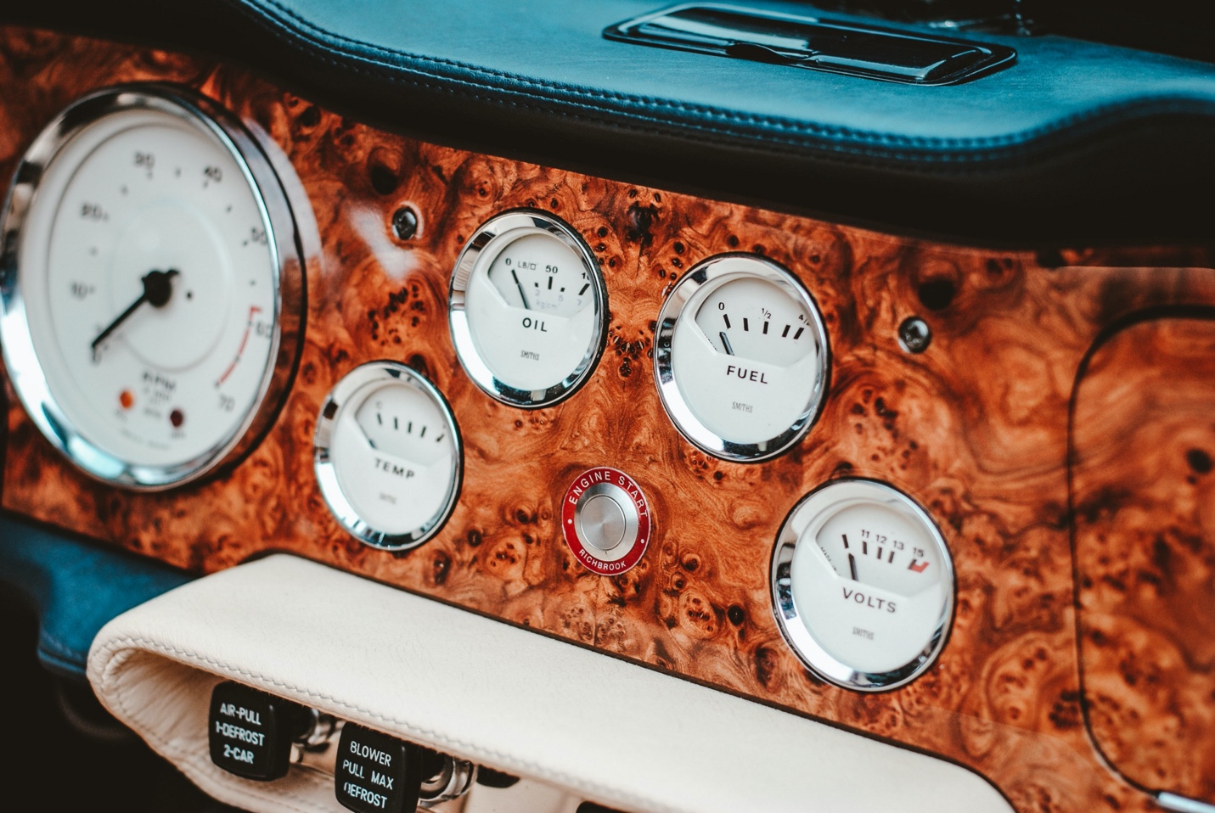Photo credit: [Unsplash](https://unsplash.com/@helloimnik)

**Executive summary**

This article describes the collection and modeling of new and used car prices in the US. Approximately 100,000 listings were scraped from Autotrader, an online vehicle marketplace, in January 2020. From this data set, empirical depreciation curves were constructed for several hundred car models, enabling comparison of value retention across car brands, body styles, and listing locations.

Depreciating faster than average are luxury cars, electric vehicles (EVs), and cars listed in areas with large seasonal temperature variation. At the other end, Japanese/Korean brands, trucks, and iconic cars were found to retain value better than most. The pricing model, an exponential fit of list price versus age, tracks value well across most of a car’s lifetime, but generally underestimates depreciation in year one and overestimates it beyond year 15. Importantly, the empirical depreciation rates obtained from this work offer a crowdsourced metric of the pleasure or pain that accompanies ownership of a particular vehicle, and may serve as a figure of merit to guide those considering a car purchase.

This project was completed during the Winter 2020 session of [Insight Data Science](https://insightfellows.com/data-science) in San Francisco, CA. The accompanying web app can be found at [www.dealsonwheels.live.](http://www.dealsonwheels.live.) The full set of measured depreciation rates across 286 make/model combinations can be found [here](https://gist.github.com/mboles01/b31837c1bee26930715cd9e2150e871c).

**Introduction**

Barring any serious lapses of judgement, the car you buy will almost certainly be the single largest depreciating asset you’ll ever hold. As a result, the difference between a smart car purchase and an uninformed one can add up to tens of thousands of dollars when it comes time to sell. Across a lifetime of car purchases, those choices may have a significant impact on what you leave to those you leave behind.

Given that there is so much at stake, it is somewhat surprising that the resources available to car buyers today don’t seem to present much in the way of concise, data-driven advice. These resources generally fall generally into one of two categories: online publications (e.g., “[Top n used cars to buy](https://www.businessinsider.com/best-used-cars-to-buy-2019-5)”) and valuation tools (think [Kelley Blue Book](https://www.kbb.com/) or [Edmunds](https://www.edmunds.com/). Each suffers from its own shortcomings: online publications are human-curated, data-light, and mention only a small subset of the available cars on the market. Valuation tools do offer pricing information on most cars, but they don’t reveal their methods, they [disagree on the numbers](https://www.investopedia.com/articles/personal-finance/113015/are-kelley-blue-book-values-accurate-and-reliable.asp), and they don’t offer actionable recommendations or lend themselves to quick comparison across models.

The key piece of information missing from this picture is [vehicle depreciation](https://www.creditkarma.com/auto/i/how-car-depreciation-affects-value/). The argument presented here is that a car’s rate of depreciation (loss in market value over its lifetime), can serve as a figure of merit to guide a car buyer’s decision. **The depreciation rate, beyond simply determining how much one recovers upon selling a car, offers a crowdsourced metric of the pleasure or pain that accompanies ownership of a particular vehicle**, not unlike the price of a particular stock reflecting the market’s assessment of future earnings of that company. Moreover, depreciation is just as important for [leased cars](https://www.investopedia.com/articles/pf/05/042105.asp) as those bought outright: monthly lease payments are based on the difference between the new price and the car’s residual value upon being returned.

**Methods**

Approximately 100,000 new and used car listings were scraped from [Autotrader](https://www.autotrader.com/) using the [Requests](https://requests.readthedocs.io/en/master/) Python package. The data was manipulated with [Pandas](https://pandas.pydata.org/pandas-docs/stable/index.html), fit with [Scipy](https://www.scipy.org/), and visualized using [Matplotlib](https://matplotlib.org/) and [Seaborn](https://seaborn.pydata.org/). The web app was developed using [Flask](https://flask.palletsprojects.com/en/1.1.x/) and hosted [here](http://www.dealsonwheels.live), and the source code can be found [here](https://github.com/mboles01/Cars).

**Results**

***1. Initial data exploration***

Approximately 100,000 currently listed new and used cars were scraped from the Autotrader web page in January 2020 across five major US metro areas (New York, Los Angeles, Chicago, Houston, and San Francisco). For each listing, features collected include price, make, model, year, mileage, location, body style, engine, transmission, and drive type.

The distribution of list prices across the set (Figure 1, left) has positive skew, with a mode of $7,000 and median price of $16,000. Reported mileage (Figure 1, center) is trimodal: a large number of new cars with zero miles (20,000 listings), a second set with approximately 30,000 miles, and a third set with about 100,000 miles. Given that the typical car is driven something like 10,000 miles per year (Figure 1, right), the abundance of cars with around 30,000 miles shown in the middle panel likely reflects listings of leased cars (typically with 24- to 48-month lease terms, and representing [one-third](https://www.statista.com/statistics/453122/share-of-new-vehicles-on-lease-usa/) of new car transactions) appearing on the market.

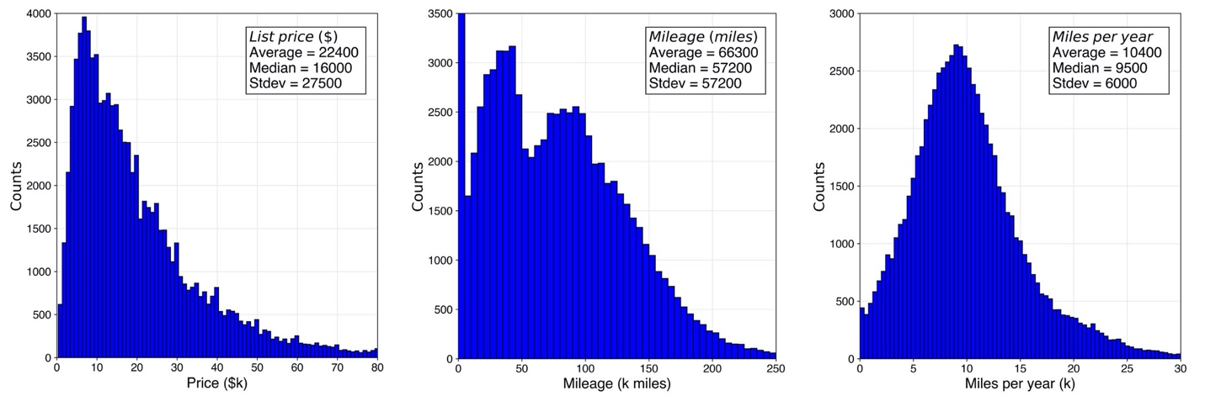**Figure 1**. Histograms of (left to right) price, mileage, and miles per year across the 100,000 listings collected from Autotrader in January 2020.

Annual [sport utility vehicle (SUV) sales](https://www.edmunds.com/car-news/sedan-dethroned-as-most-popular-body-style-in-america.html) exceeded those of sedans for the first time in 2014. This fact is already reflected in Autotrader listings, which show nearly 20% more SUVs than sedans (Figure 2, left). Together, SUVs and sedans make up more than half of cars on the market. On the other hand, the popularity of minivans has turned in the opposite direction: [three times more popular](https://www.freep.com/story/money/cars/2019/08/02/minivan-sales/1898974001/) in the year 2000 than they are today, minivans are beside station wagons at the bottom of the list.

Despite retaining just 10% of the US market, the truck segment lays claim to the most popular (by far) car in America, the Ford F-150 (Figure 2, right). The top ten most frequently encountered cars in this data set include four sedans (the midsize- and compact offerings of Camry, Accord, Civic, and Corolla from Toyota and Honda), four SUVs (Jeep’s Grand Cherokee and Wrangler alongside the Honda CR-V and Toyota Highlander), and two trucks (the aforementioned Ford F-150 and Chevrolet Silverado 1500). One luxury offering made it into the top 20: the BMW X5.

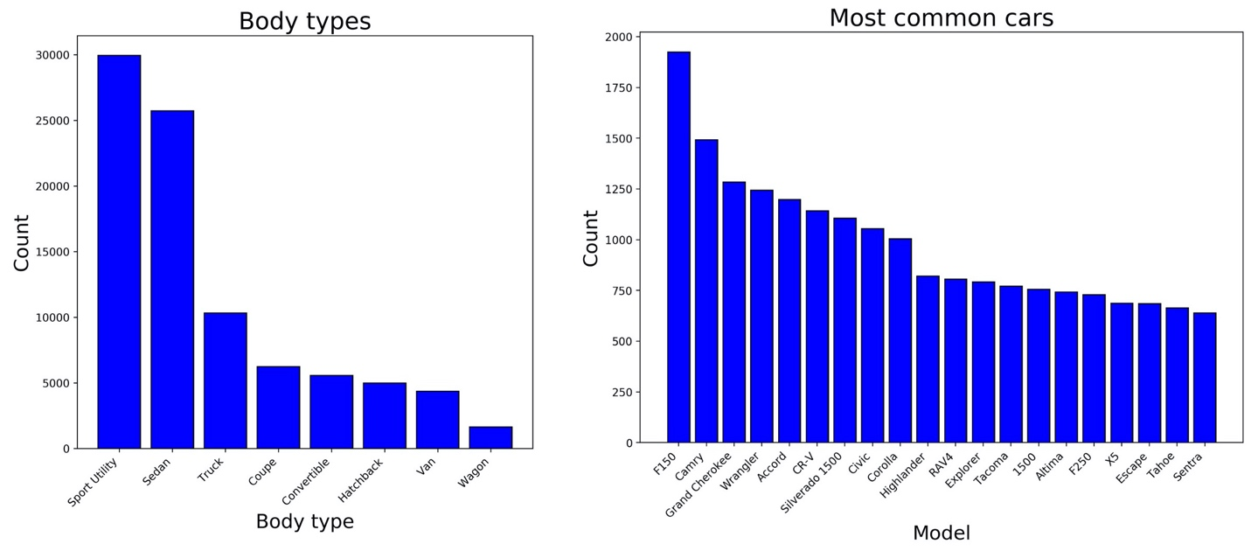**Figure 2**. Bar plots showing number of listings by body type (left) and the most popular 20 models (right).

***2.* *Price modeling***

***A. Price versus age and miles***

With hundreds to thousands of individual listings collected for each of hundreds of car models, the evolution of price was evaluated across vehicle lifetime for each car model. For instance, Figure 3 shows approximately 1500 listings of the Honda Civic plotted in 3D, with x, y, and z-coordinates reflecting vehicle age, mileage, and price.

A surface of best fit was obtained by fitting an exponential regression against age and price of the form

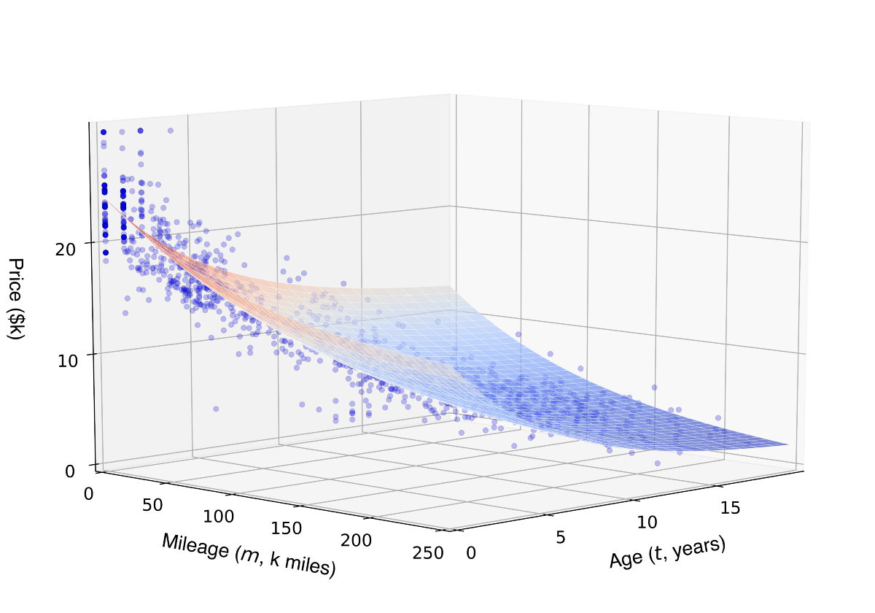**Figure 3**. List price versus age and mileage for 1500 Honda Civic listings (blue scatter data) and corresponding surface of best fit obtained from Equation 1.

where price ***P*** is a function of age ***t*** and mileage ***m****.* The new car price is captured by the constant ***a***, while ***b*** and ***c*** are the decay coefficients against age and mileage, respectively. The bias term ***d*** represents the terminal value of the car. Because a typical scrap car commands [less than $300](https://www.junkcarmedics.com/blog/scrap-car-prices-per-ton/) at the junkyard, this term was left out of the fit (i.e., ***d*** = 0).

***B. Univariate analysis: price versus age or miles***

For most car models, the surface of best fit described by Eq. 1 explains approximately 90% of the observed variance in price (*R*² ≈ 0.90). When viewing the same 1500 listings in just two dimensions, either price versus age (Figure 4, left) or price versus miles (Figure 4, right), only a small sacrifice in fit quality (*R*² ≈ 0.85) is observed.

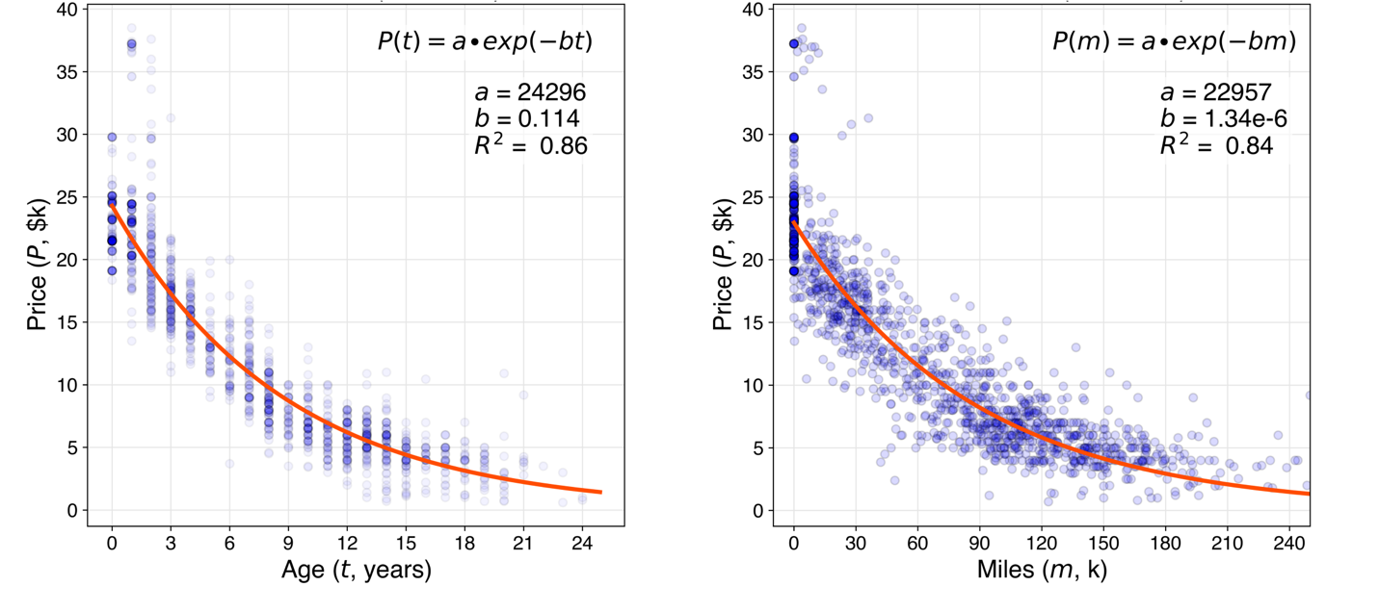**Figure 4**. Scatter plot of price versus age (left) and price vs. mileage (right) for 1500 Honda Civic listings. The text inset describes exponential decay functions and resulting parameters from curve fitting. For the Civic, and for most other cars in the data set, choosing age as the predictor of price affords slightly better fit quality.

In each case, fitting exponential decay functions of the form



with independent variable choice ***x*** (either age or mileage) allows for extraction of the typical new car price ***a*** and the decay coefficient ***b***.

In the case of the Honda Civic, exponential fit of price vs. age (Figure 4, left) yields an estimated new car price of $24,300 and decay coefficient of 0.114 1/years.

One convenient aspect of modeling car depreciation with an exponential function is it lends itself to half-life (***t*₁/₂**) calculation:



where ln(2) ≈ 0.693 is the natural logarithm of 2 and ***b*** is the decay coefficient determined by exponential fit. The half-life of a particular car model is the amount of time required for the price to halve its initial value. A longer half-life is desirable, indicating the car depreciates more slowly.

***C. Model selection***

While the model constructed with both vehicle age and mileage (Eq. 1) offers a slightly better fit quality than a univariate model (Eq. 2), the latter yields just one decay coefficient (***b***) instead of two (***b*** and ***c***), and thus offers a convenient single metric, or figure of merit, describing vehicle value retention.

Fit quality (*R*²) was then used to decide between age and mileage as the best univariate predictor of price. Across the most frequently encountered listings, age seems to do better than miles (Figure 5 left, blue versus orange bars). There is, however, a small subset of models that show the opposite trend. For cars such as the Ford Mustang, Chevy Camaro, and Dodge Challenger, age turns out to be a poor predictor of list price (Figure 5 middle). In these cases, there is a huge variation in price for the oldest models: while some may be on their way to the junkyard, others are trading hands for many multiples of their original MSRP. For cars with this sort of vintage appeal, it is difficult to estimate value and, as a result, depreciation rates.

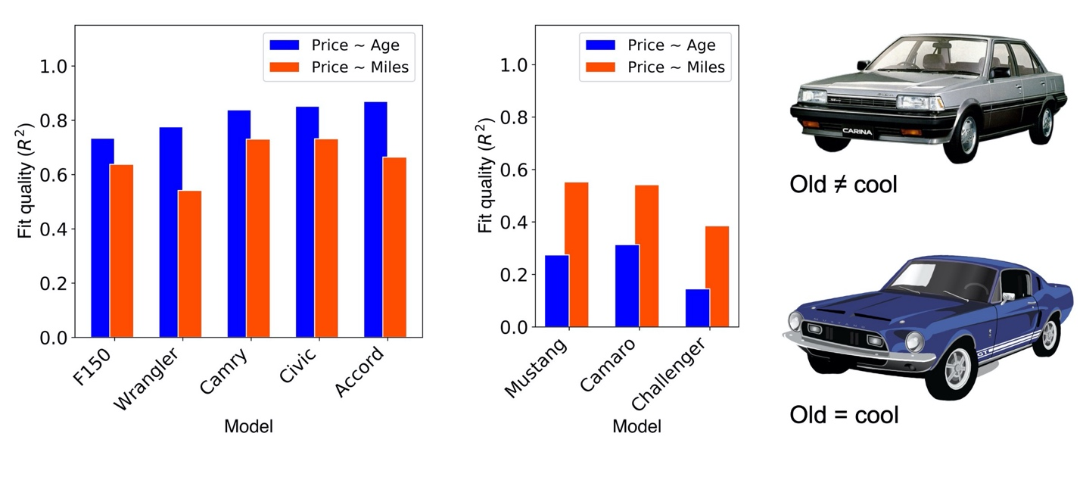**Figure 5**. Bar plot showing comparison of fit quality using age or mileage (blue and orange bars, respectively) as univariate predictor of price for top five most common cars (left) and selected cars with vintage appeal (center). Vehicle age, typically the better measure of a car’s value, is a poor predictor of price for a few special cases where some of the oldest examples happen to be the most desirable.

***3.* *Depreciation analysis***

***A. Outliers: best and worst in value retention***

For each of several hundred make/model combinations present in the Autotrader dataset, listing data was fit according to Eq. 2 using vehicle age as the independent variable (Figure 4, left). Empirical depreciation curves for cars with a small number of observations (< 50 listings) or anomalous pricing (e.g., vintage appeal) typically yielded poor fit quality. To avoid drawing spurious conclusions from poorly understood pricing, a fit quality filter (*R*² > 0.67) was applied.

Across 178 models with well-characterized pricing, the observed range of vehicle half-lives spans two to ten years, with most cars typically experiencing a five-year half-life (Figure 6, center). Among the fastest-depreciating cars are electric vehicles (EVs) and foreign luxury cars, while those that retain their value the longest are simple, mass-produced, and arguably iconic cars (Figure 6, left and right).

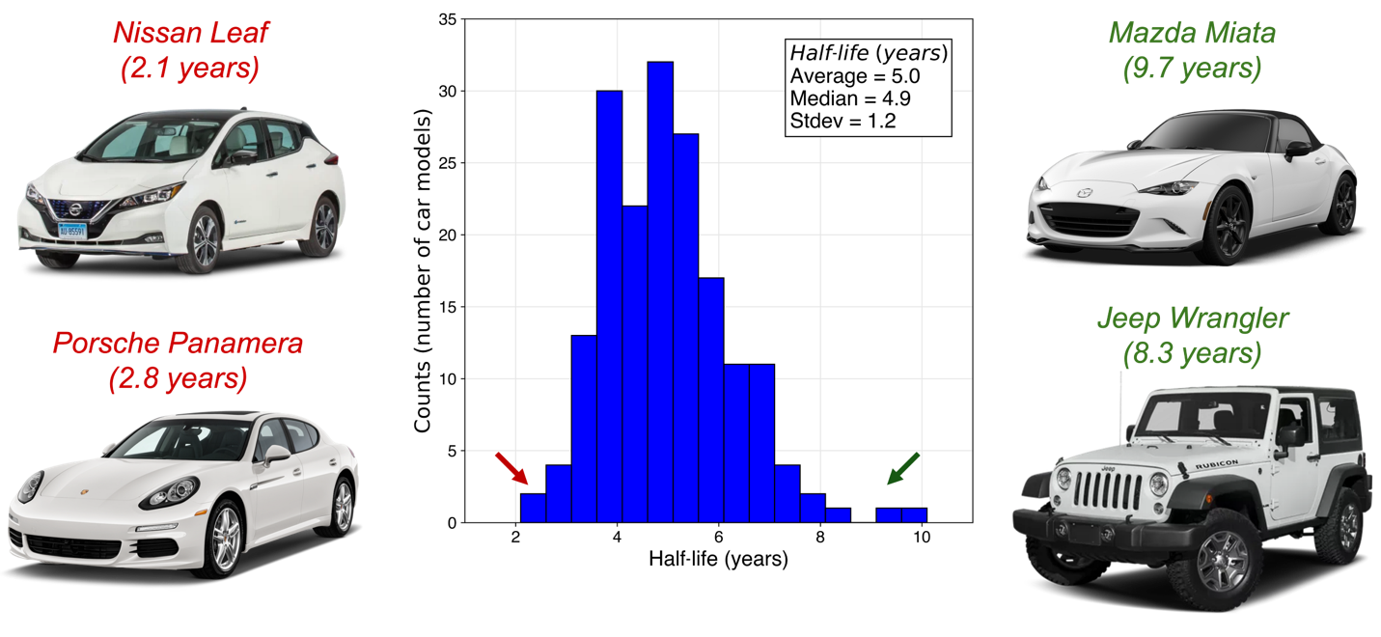**Figure 6**. Histogram (center) displaying vehicle half-life estimates across 178 models. Each count was obtained by extracting the coefficient of exponential decay as shown in Figure 4 for hundreds (or thousands) of individual Autotrader listings for a particular model. Prototypical examples of quickly-depreciating and slowly-depreciating vehicles are shown at left and right, respectively.

Perhaps unsurprisingly, foreign luxury cars are close to the bottom of the list when it comes to value retention. One likely contributing factor is the high [maintenance costs](https://www.businessinsider.com/10-cars-lose-the-most-value-last-5-years-2019-10) that accompany ownership of such cars. In addition, the inevitable blemishes and dated appearance that used cars bring may be particularly undesirable to used luxury car buyers, who are almost certainly more image-conscious than the average buyer.

This analysis also indicates that the depreciation rate for EVs appears to be surprisingly harsh. Some of this effect may be artificial, since the $7500 Federal tax credit on the purchase of new EVs, which will be [phased out](https://cleanvehiclerebate.org/eng/ev/incentives/state-and-federal) over 2020, is not available to used EV buyers and is thus immediately dropped off the used car sticker price. Even so, consumers seem to perceive EV technology as one that is advancing rapidly, and that used EVs may be (by definition) outmoded. In addition, range anxiety might be more pronounced in the used EV market: batteries begin to [lose cruising range](https://www.myev.com/research/ev-101/how-long-should-an-electric-cars-battery-last) at 100,000 miles and may need replacement (at a cost upwards of $15,000) when the odometer approaches 200,000 miles. Interestingly enough, it seems as though the Tesla brand might be a slight [exception](https://www.greencarreports.com/news/1123583_beyond-tesla-electric-cars-lose-value-faster-than-other-vehicles) to the EV depreciation rule, possibly related to the [consensus](https://www.tesloop.com/blog/2019/2/6/tesla-and-the-electrifying-economics-of-depreciation) that Teslas enjoy a more robust battery life, drivetrain, and sensors. In the analysis presented here, half-life estimates of approximately 5 years for the Tesla Model S and Model X place them in the middle of the pack, although fit quality (*R*² < 0.5) indicates this figure should be interpreted with some caution.

At the other end of the spectrum, the Mazda Miata and Jeep Wrangler are some of the best performers when it comes to value retention. These cars, and others that appear to retain their value well, are affordable, mass-produced, and have been in production for several decades.

Cars that do well in terms of value retention are shown in Table 1. This table displays, for a given make and model, the new price (extracted as fit parameter ***a***, in dollars), the rate of decay (fit parameter ***b***, with units 1/years), the resulting half-life (in years), and the fit quality (*R*² value, or fraction of observed variance that is explained by the model). Six of the top 10 cars for value retention belong to Japanese brands (Toyota, Nissan, Mazda, Honda), while the other four are American (Jeep, Ford, GMC). These cars typically lose half their value every 7 to 10 years, and are disproportionately entry-level or utility-focused.

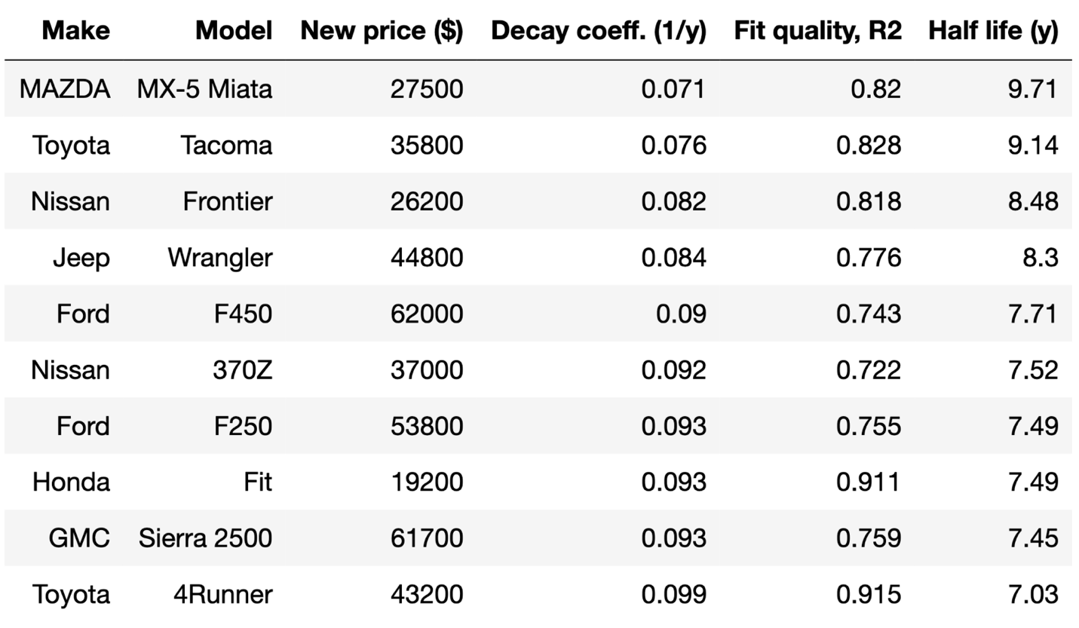**Table 1**. Top ten cars for value retention.

At the other end of the spectrum, cars that appear to lose value the quickest are shown in Table 2. Seven of the bottom ten cars for value retention are luxury offerings, and most of them are German (Porsche, VW, Audi, Mercedes). On average, these cars are twice as expensive as those appearing in Table 1, and two of the bottom three are EVs (the Nissan Leaf and VW e-Golf). Cars with poor fit statistics (*R*² < 0.67) were excluded from both Tables 1 and 2.

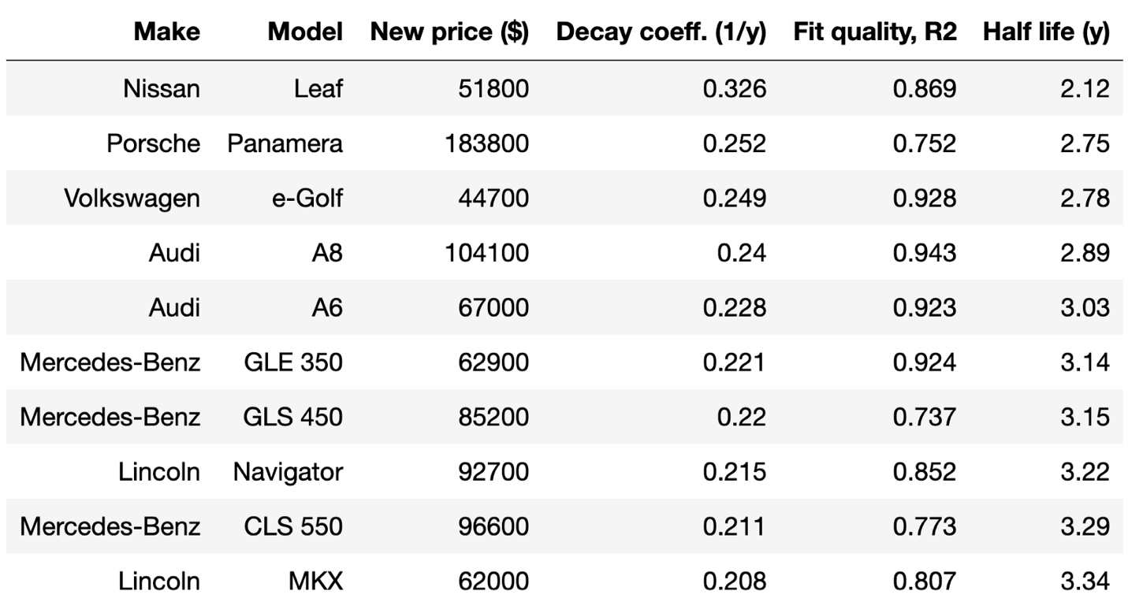**Table 2**. Bottom ten cars for value retention.

In striking contrast to those displayed in the previous table, these cars lose half their value every 2 to 3 years. To put this into perspective: a $50,000 car with seven-year half-life can be sold for $25,000 after seven years, while one with a three-year half-life is worth less than $10,000 after the same period. Put another way: choosing a slowly-depreciating car over a similarly-priced, quickly-depreciating one is, upon selling after seven years, equivalent to receiving into your bank account a transfer of 30% of the initial value of the vehicle.

The fast pace of value loss on cars presented in Table 2 also serves as a harbinger of problems or excessive costs that are frequently encountered specific to that particular vehicle. For example, Nissan Leaf owners have experienced unusually steep decline in cruising range due to [poor thermal management](https://cleantechnica.com/2018/09/29/nissans-long-strange-trip-with-leaf-batteries/) of the battery pack. The Porsche Panamera has been reported to suffer from overheating engines as a result of [burning oil](https://www.pcarshops.com/porsche-panamera-970-common-problems), with the unfortunate addendum that a Panamera oil change [costs nearly $500](https://repairpal.com/estimator/porsche/panamera/oil-and-filter-change-cost). Generally speaking, the [total maintenance cost](https://www.yourmechanic.com/article/the-most-and-least-expensive-cars-to-maintain-by-maddy-martin) over ten years of car ownership can exceed $15,000 for a German make, while the same for Japanese brands appears to be less than half this figure.

***B. Depreciation across car makes***

Perhaps more interesting than comparing empirical depreciation rates across individual car models is looking at trends in the aggregated data across axes such as brand, body style, and location.

To this end, the 178 car models with well-characterized pricing (*R*² > 0.67 for exponential fit of price versus age) were grouped by car make, and the corresponding half-lives were visualized in a box plot (Figure 7). Across all brands, typical half-lives span 3 to 6 years. Strikingly, the 10 brands that appear to lose their value the quickest are all in the luxury segment. Among luxury offerings, Lexus and Acura stand out with their solidly average half-lives of about 5 years. At the other end of the spectrum, 4 of the best 5 car brands for value retention are either Japanese or Korean. Hyundai and Toyota are at the top of this list, with all models (except for their luxury models, the Genesis and Avalon) showing half-lives above 5 years.

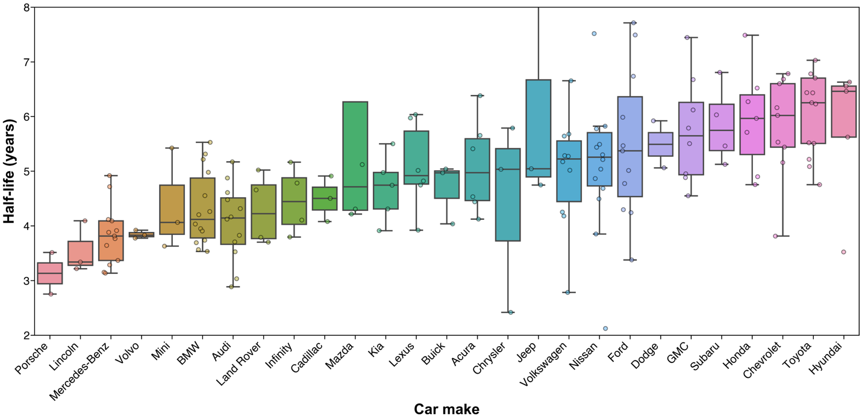**Figure 7**. Comparison of depreciation rates, expressed in terms of half-life, across car brands. For each make, the colored box denotes the interquartile range (25th to 75th percentile), the line within it denotes the median value, and the whiskers encompass the remainder of the distribution minus outliers. Each scatter point represents, for a particular model, the decay coefficient resulting from exponential fit of hundreds or thousands of individual Autotrader listings.

***C. Depreciation across body styles***

Beyond car make, empirical depreciation rate trends across body type (coupe, sedan, SUV, truck, or van) were also explored. In this case, each of the 180 models with well-characterized pricing (*R*² > 0.67) was grouped by body type, and corresponding half-lives were visualized in a box plot (Figure 8).

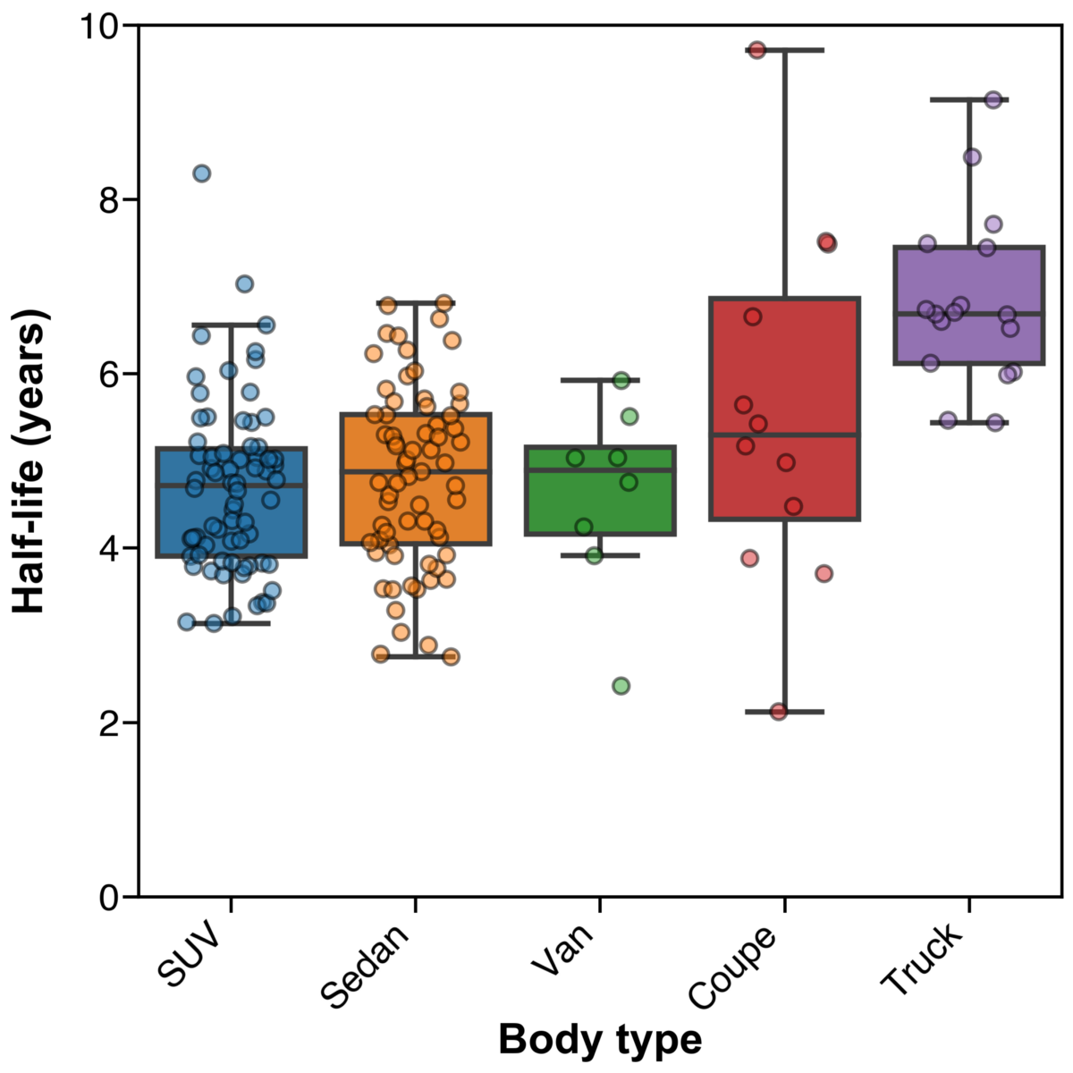**Figure 8**. Comparison of vehicle half-lives across the five main body styles. Trucks appear to retain their value much longer than the others.

Here, trucks clearly stand out for value retention. While SUVs, sedans, vans, and coupes all show median half-lives just under 5 years, trucks enjoy a 6.5-year median half-life. Without knowing exactly why this might be, one might speculate that trucks retain their value better than other body types due to: 1) tougher building materials resulting in comparatively reduced wear over a similar ownership period, 2) more conservative styling changes from year-to-year meaning that old trucks look less old than similarly-aged models in other body styles, and 3) a simpler use-case for trucks (i.e., hauling cargo in the bed) meaning that old and new trucks perform similarly along this dimension.

On the other hand, over the past couple of years, the American consumer is increasingly [seeking out luxury offerings](https://www.nytimes.com/2018/02/15/automobiles/wheels/luxury-trucks-suv.html) within the truck segment, often spending upwards of $70,000 on a Ford, Chevrolet, or GMC truck with premium aesthetics and new technology. To the extent that trucks are moving away from their historical role as the utilitarian choice, one might expect truck depreciation rates to be pushed down and become aligned with those of the rest of the market.

***D. Depreciation across geographies***

The influence of geography on observed vehicle depreciation rates was also evaluated. In this case, listings of the top ten most frequently encountered models (F-150, Camry, Grand Cherokee, Wrangler, Accord, CR-V, Silverado, Civic, Corolla, and Highlander) were split by geography, and exponential decay models were fit to each model-city pair. The corresponding half-lives grouped by listing location were visualized with a box plot (Figure 9).

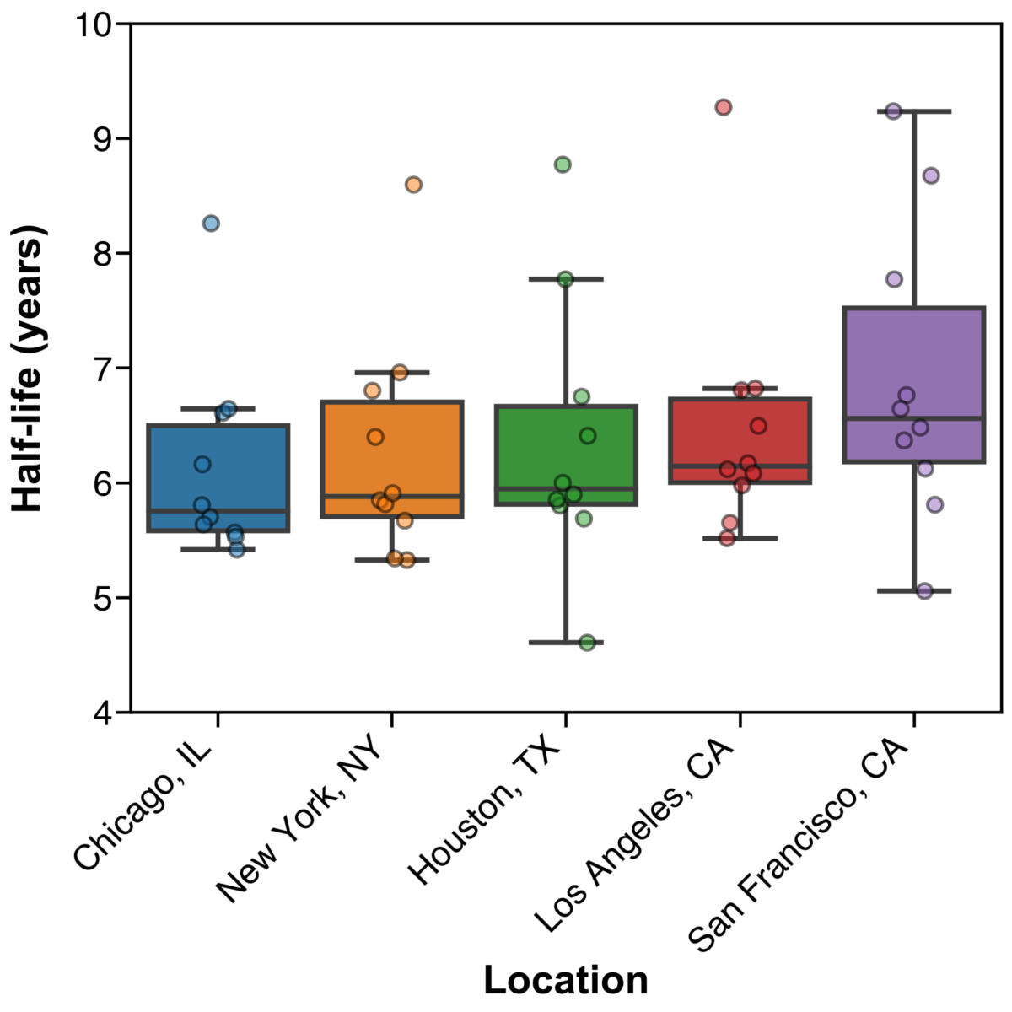**Figure 9**. Effect of listing location on depreciation rate. Scatter data shows the location-specific half-life for each of the ten most frequently encountered models.

Perhaps unsurprisingly, value retention for these selected cars scales inversely with seasonal temperature variation. For instance, the same cars experience a 15% longer half-life in San Francisco (6.6 years) than they do in Chicago (5.8 years).

Given the additional exterior wear on cars driven in cold climates (salty roads increase paint abrasion, leading to rust), and the [45% increase in crash frequency](https://www.ncbi.nlm.nih.gov/pmc/articles/PMC1449863/) in snowy weather, it may come as no surprise that the market applies a steeper markdown for cars listed in the Midwest than those coming from coastal California.

Also interesting is the possible discount applied to cars coming from hot climates. While snow is seen in Houston only slightly more often than in Los Angeles or San Francisco, Houston heats up much more in the summertime (average August high temperature of 95ºF) than the other two (84ºF and 68ºF, respectively). Sun and heat contribute to discoloration and cracking of the vehicle exterior and interior. In addition, engine oil and coolant, like all liquids, have higher vapor pressure in elevated temperatures. Cars routinely driven in hot climates are thus more susceptible to [loss of these fluids](https://www.holtsauto.com/prestone/news/hot-weather-car), which can result in overheating, and in the extreme case, engine seizure.

***E. Depreciation by time in production***

Two leaders in value retention happen to be two of the oldest models on the market (the Jeep Wrangler and Mazda Miata, Figure 6), suggesting the possibility of a correlation between the time a vehicle has been in production and its depreciation rate. Exploring this, the number of distinct model years with nonzero listing counts was used as a proxy for the number of years that a particular model has been in production.

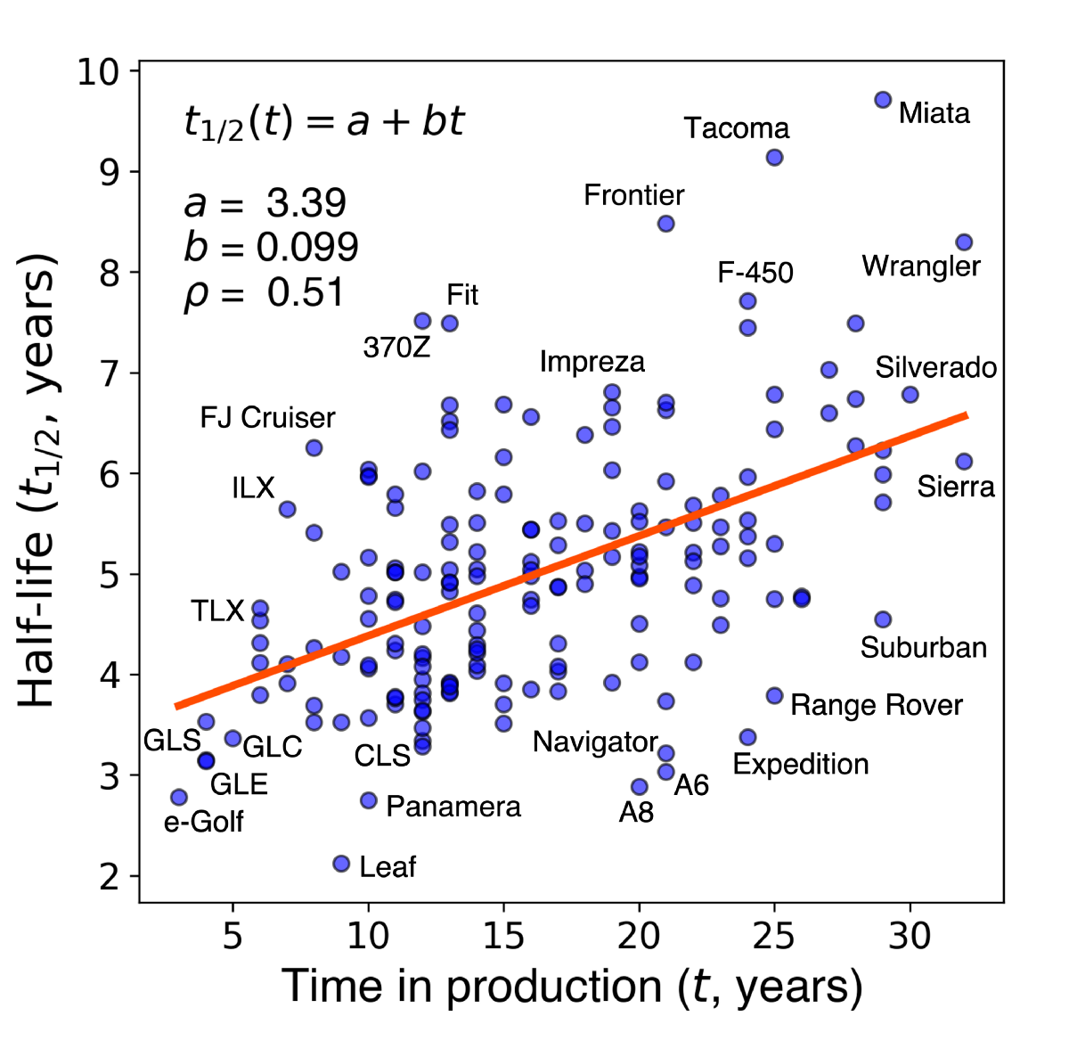**Figure 10**. Scatter plot of time in production versus measured half-life for 178 cars with well-characterized pricing.

For each of the 178 models with well-characterized pricing, measured half-life was plotted against time in production (Figure 10). A reasonably strong positive relationship (Pearson correlation coefficient, *ρ*, of 0.51) was observed between years in production and measured half-life, with the line of best fit implying that, on average, for every ten years of model history an additional year is added to half-life.

Beyond this general relationship, it’s interesting to note which cars deviate from the trend. While most new or short-lived models are generally not coveted by the market, the Toyota FJ cruiser appears to be [on its way to collector status](https://www.hagerty.com/articles-videos/articles/2017/10/31/toyota-fj-cruiser). At the other end, while some established models like the Wrangler and Miata enjoy robust demand in the second-hand market, others like the Suburban and Range Rover appear to lose value relatively quickly.

***4.* *Model validation***

A quick check of model performance can be run by comparing the best and worst performers (Tables 1 and 2) in value retention generated by fitting Autotrader listing data with automotive resources. Indeed, there is remarkable overlap between the results presented in this study and [depreciation data presented by others](https://www.iseecars.com/cars-that-hold-their-value-study#v=2019).

***A. General cases of prediction error***

One might also wish to assess the choice of an exponential function (Eq. 2) to model the value of a car over its lifespan. This simple approach has a few key advantages: 1) the resulting fit parameters ***a*** and ***b*** are easily interpretable, 2) the decay coefficient ***b*** can be used as a figure of merit for value retention, and 3) with just two fit parameters, the regression converges quickly and is robust against overfitting.

To evaluate how well the exponential approximates observed list prices over time, the prediction error ***ε*** for a given car of age ***t*** was calculated as the difference between the observed and predicted price, normalized by the new car price ***P*ₒ**, according to the expression



The average prediction error, or residual, was calculated as the arithmetic mean of prediction errors across ***n*** cars



The residual was plotted (Figure 11, grey traces) for each of the 50 most frequently encountered models (***n*** = 50), together with the average and 25th/75th percentile residuals in the data set (red solid and dotted traces, respectively). In the ideal case, these traces would all be flat lines at zero, indicating perfect match between predicted and observed list price. In practice, however, the deviation of observed price from the prediction is typically a few percent of the new car price.

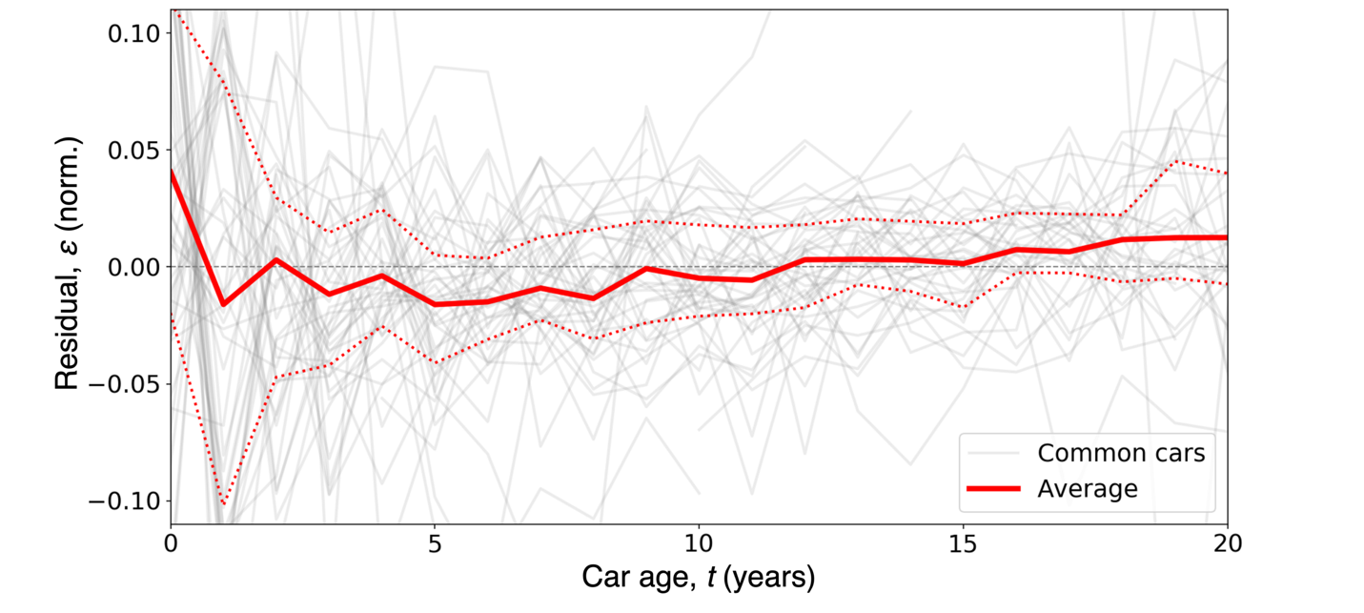**Figure 11**. Difference between observed and predicted list price for the 50 most common cars (grey traces), along with average difference (solid red line) and 25th/ 75th percentile differences (dotted red lines) over two decades of vehicle ownership. Negative average values early on, and positive values later in the vehicle lifetime, suggest that the true depreciation rate of a typical car is not constant but decreases slightly over time (i.e., db/dt < 0).

Most interesting is the systematic deviation of observed prices from predicted prices when averaged across all cars. From the averaged data (red trace) it’s clear that exponential regression tends to underestimate new car prices: at year zero, the list price is about 4% higher than the predicted price, while for one-year-old cars, the list price is nearly 2% lower than the predicted price. This implies that new cars, on average, depreciate about 6% faster in their first year than indicated by the exponential model (Eq. 2), and supports the idea that car depreciation may be best expressed as a [piecewise function](https://www.free-online-calculator-use.com/car-depreciation-calculator.html), splitting the first year from the rest of the vehicle lifespan.

Similarly, the negative residual between years one and ten suggests that younger used cars depreciate more quickly than the exponential best fit model would predict. At the other end, towards the end of life (beyond 15 years), average list prices consistently exceed the predicted price, implying that depreciation slows for older cars. The true rate of depreciation for a typical car is thus not constant, but varies slightly across that car’s lifetime. A more sophisticated model of car value over time might fit individual segments of the vehicle lifetime or allow for the exponential decay coefficient ***b*** in Eq. 2 to itself be a function of vehicle age.

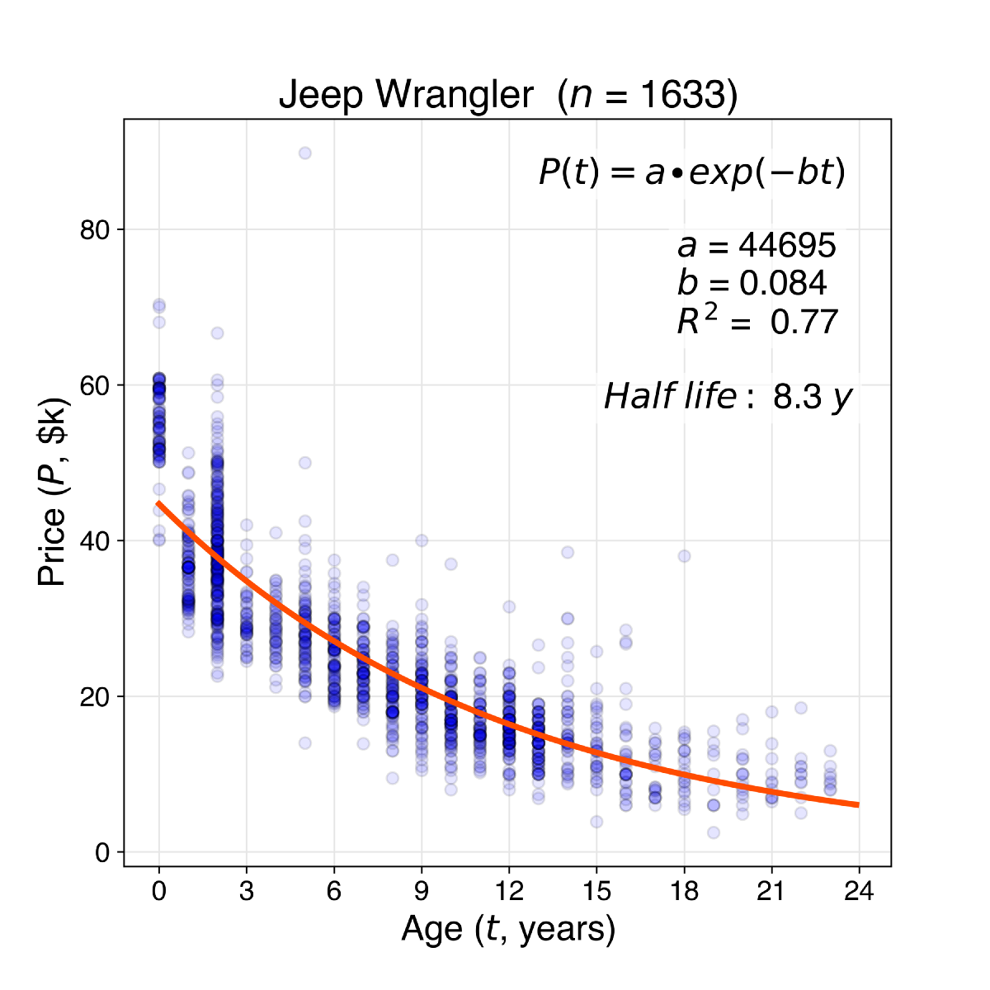**Figure 12**. List prices for 1633 examples of the Jeep Wrangler listed on Autotrader as of January 2020 (blue scatter data) and resulting exponential curve of best fit for price versus age (orange trace). Deviation between observed and predicted price at year zero and years 15+ illustrate the principle limitation of this simple exponential decay model.

Quick depreciation during a car’s first year and slowing depreciation after 15 years can be seen in the canonical case of the Jeep Wrangler (Figure 12). The observed price drop from years 0 to 1 is much steeper than what’s implied by the line of best fit. This discontinuity between first-year depreciation and that of subsequent is perhaps unsurprising, given the car’s abrupt transition from “new” to “used” when the odometer loses some of its zeros. At the other end of the ownership lifetime, most listings of 20+ year old Wranglers are priced above the prediction line. From this it’s clear that depreciation on senior cars (particularly if they have vintage appeal, see also Figure 5) is also somewhat different from earlier in its life.

***B. Price discontinuity across a model redesign***

It’s clear that the exponential function might underestimate depreciation in year 0 and overestimate depreciation in years 15+ (Figures 11, 12). Another failure mode of this simple exponential price model involves price discontinuities across significant redesigns of a particular car.

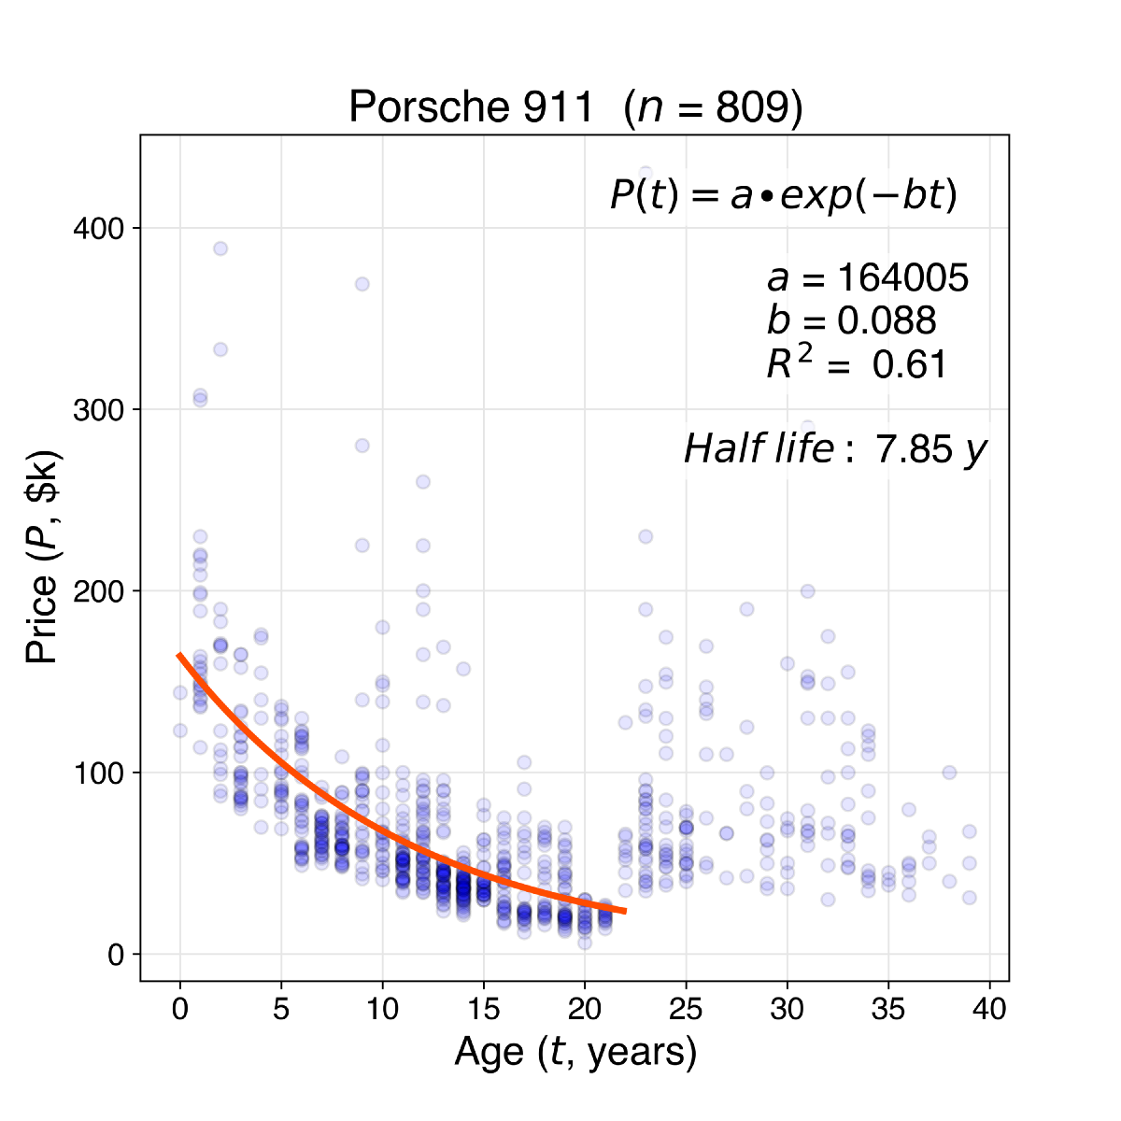**Figure 13**. List prices for 809 examples of the Porsche 911 (blue scatter data) and resulting exponential curve of best fit for price versus age (orange trace), excluding vehicles older than 22 years. The discontinuity in list prices at year 22 points to a special case of limitations of the simple exponential decay model for car prices.

The Porsche 911 offers perhaps the most striking example of such a phenomenon (Figure 13). In 1998, the “993” version of the 911, [referred to by enthusiasts](https://en.wikipedia.org/wiki/Porsche_993#Media) as the “best and most desirable of the 911 series,” and the “last modern classic” was replaced by the “996” version. Spurred by Porsche’s financial troubles in the late ’90s, the “996” 911 borrowed many components with the more economical Boxster cousin. As a result, the market values 911s from 1999 far below ($21,000 average price) the 1998 production year ($57,000). In such cases, eyeballing the scatter data itself can be more informative than referring to an extracted half-life measurement.

***C. Rare/collectible models***

One final failure mode of the exponential pricing model is centered around scarcity of a particular car. The most salient example is the Toyota FJ Cruiser, introduced in the US in 2006 and phased out in 2014 due to poor sales. While Jeep sold 230,000 Wranglers in the US last year, Toyota sold about that same number of FJs across all 8 years of its production.

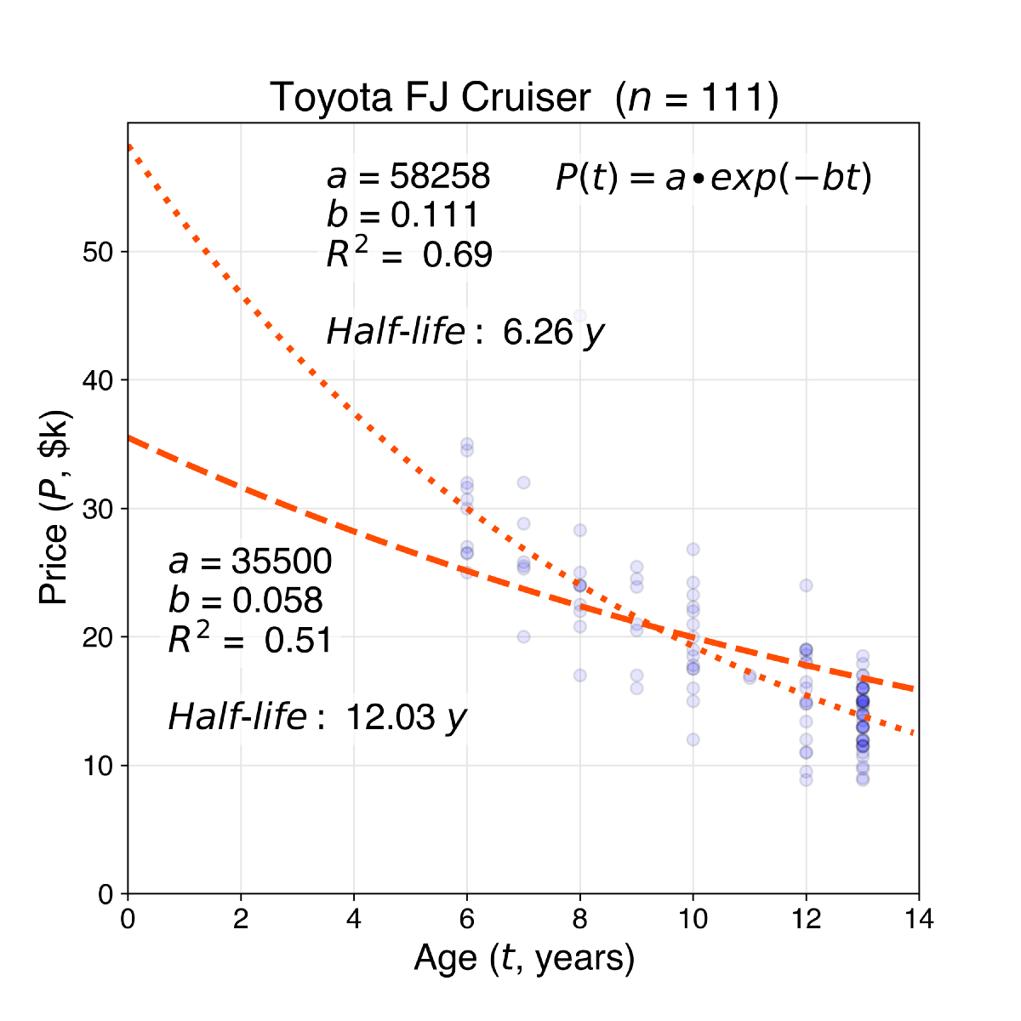**Figure 14**. List prices for 111 examples of the Toyota FJ Cruiser (blue scatter data) and exponential curves of best fit for price versus age unconstrained (dotted orange trace) or with the new car price fixed to the inflation-adjusted 2014 median sale price (dashed orange trace).

Perhaps because of this relative shortage, and the collector status of its older FJ40 cousin, many used FJ Cruisers are now [trading hands](https://www.hagerty.com/articles-videos/articles/2017/10/31/toyota-fj-cruiser) for upwards of 90% of their new price. For this reason, the FJ Cruiser is another edge case for depreciation modeling (Figure 14). An unconstrained exponential fit yields a new price of $58,000 and half-life of 6.3 years, while fixing the new price at the inflation-adjusted median sale price of the 2014 model ($35,500) produces a record-setting half-life estimate of 12 years. In such cases, there may be a speculative component to pricing, with buyers making offers on the hunch that the vehicle might actually appreciate under their ownership.

**Conclusions**

In summary, approximately 100,000 Autotrader listings were scraped in January 2020, and observed list prices were fit to an exponential versus car age to obtain empirical depreciation curves for each make/model combination. The vehicle half-life was extracted from coefficient of exponential decay and used as a simple measure of how well a particular car retains its value.

The ends of the depreciation distribution were examined — electric vehicles and foreign luxury cars typically lose their value the fastest, while cars that have some sort of iconic or utilitarian appeal typically retain their value the longest. Binning depreciation rates by car make, the ten brands losing their value the fastest all belong to the luxury segment, while four of the top five for value retention are Japanese or Korean. Trucks retain their value longer than other body styles, and depreciation rates are faster for vehicles listed in areas with large seasonal temperature variation.

On average, the exponential pricing model tends to underestimate the rate of depreciation for newer cars and overestimate it for older cars — the true rate of depreciation is not constant but varies across the life of a car. Along the same lines, the exponential pricing model breaks down for a few edge cases including rare/collectible/vintage vehicles and changes in desirability across a significant model redesign.

***Key takeaways and tips for frugal car buying***

***1. All cars lose a lot of value in year one***

A typical one-year-old car has 95% of its life remaining but sells for 75% of its new price. More generally, slightly used cars (with less than 50,000 miles on the odometer) are a relative deal, and lease expirations guarantee an abundance of such models on the market (Figure 1, middle). This is probably a good place to start looking for a car.

For the same reason, leasing a new car is costly: in addition to paying interest, you’re compensating the lessor for the period of steepest value decline of that car. Similarly, long-term (6- or 7-year) car loans put the borrower underwater immediately and often lead to the unfortunate situation of [negative equity rollover](https://www.nerdwallet.com/blog/loans/5-reasons-say-no-long-lo/). These options are not recommended.

***2. Some cars lose value faster than others***

Luxury cars and electric vehicles tend to depreciate quickly. With expensive maintenance, drivers of German luxury brands experience a larger total cost of ownership. This is reflected in the high depreciation rate, which amounts to a counterbalancing discount offered to those who buy these cars used and bear the associated maintenance costs. Among luxury cars, Lexus and Acura appear to be above average in value retention, and might be a more reasonable option for those looking for a premium experience without the financial hit.

Electric vehicles (EVs) also appear to lose value more quickly than others, potentially due to rapidly advancing technology, range anxiety, tax incentives, and potentially expensive battery replacement. Among EVs, preliminary evidence suggests that the Tesla brand retains value better than its competitors, and may therefore be worth looking into.

At the other end of the spectrum, Japanese/Korean brands, trucks, and iconic cars depreciate slowly. The Toyota Corolla, Toyota Tacoma, Mazda Miata, and Jeep Wrangler are the top performers in the sedan, truck, coupe, and SUV segments, respectively. Based on observed value retention, one might anticipate strong owner satisfaction and high resale value.

**Measured depreciation rates — full data set**

**Table 3.** Measured car depreciation rates by make/model.